MACH4METAL

metalworking machinery
Transito 21,
6909 DA BABBERICH, Netherlands
Tel. + 31 (0)316 – 247123
Fax. + 31 (0)316 - 247956
info@mach4metal.com
www.mach4metal.com

Bank No : 66.52.13.883
IBAN : NL33 INGB 0665 2138 83
BIC : INGBNL2A

STANKO Vertical Borer Ø 8000
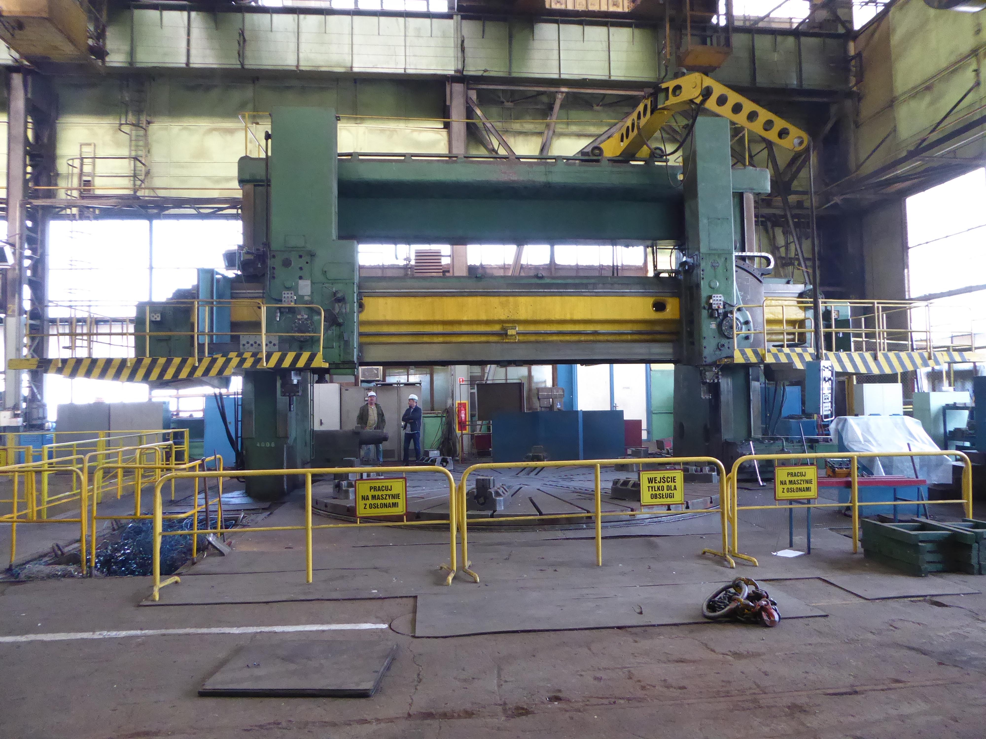
- Make : STANKO RUSSIA
- Typ : 1580 Type L
- Age : 2006 Overhauld
- Serial No : 62

- Chuck Ø : 7.100
- Max. turning Ø : 8.000
- Max. turning height table-rail : 3.240

- Hor. Travel left support : X1 : 2.000
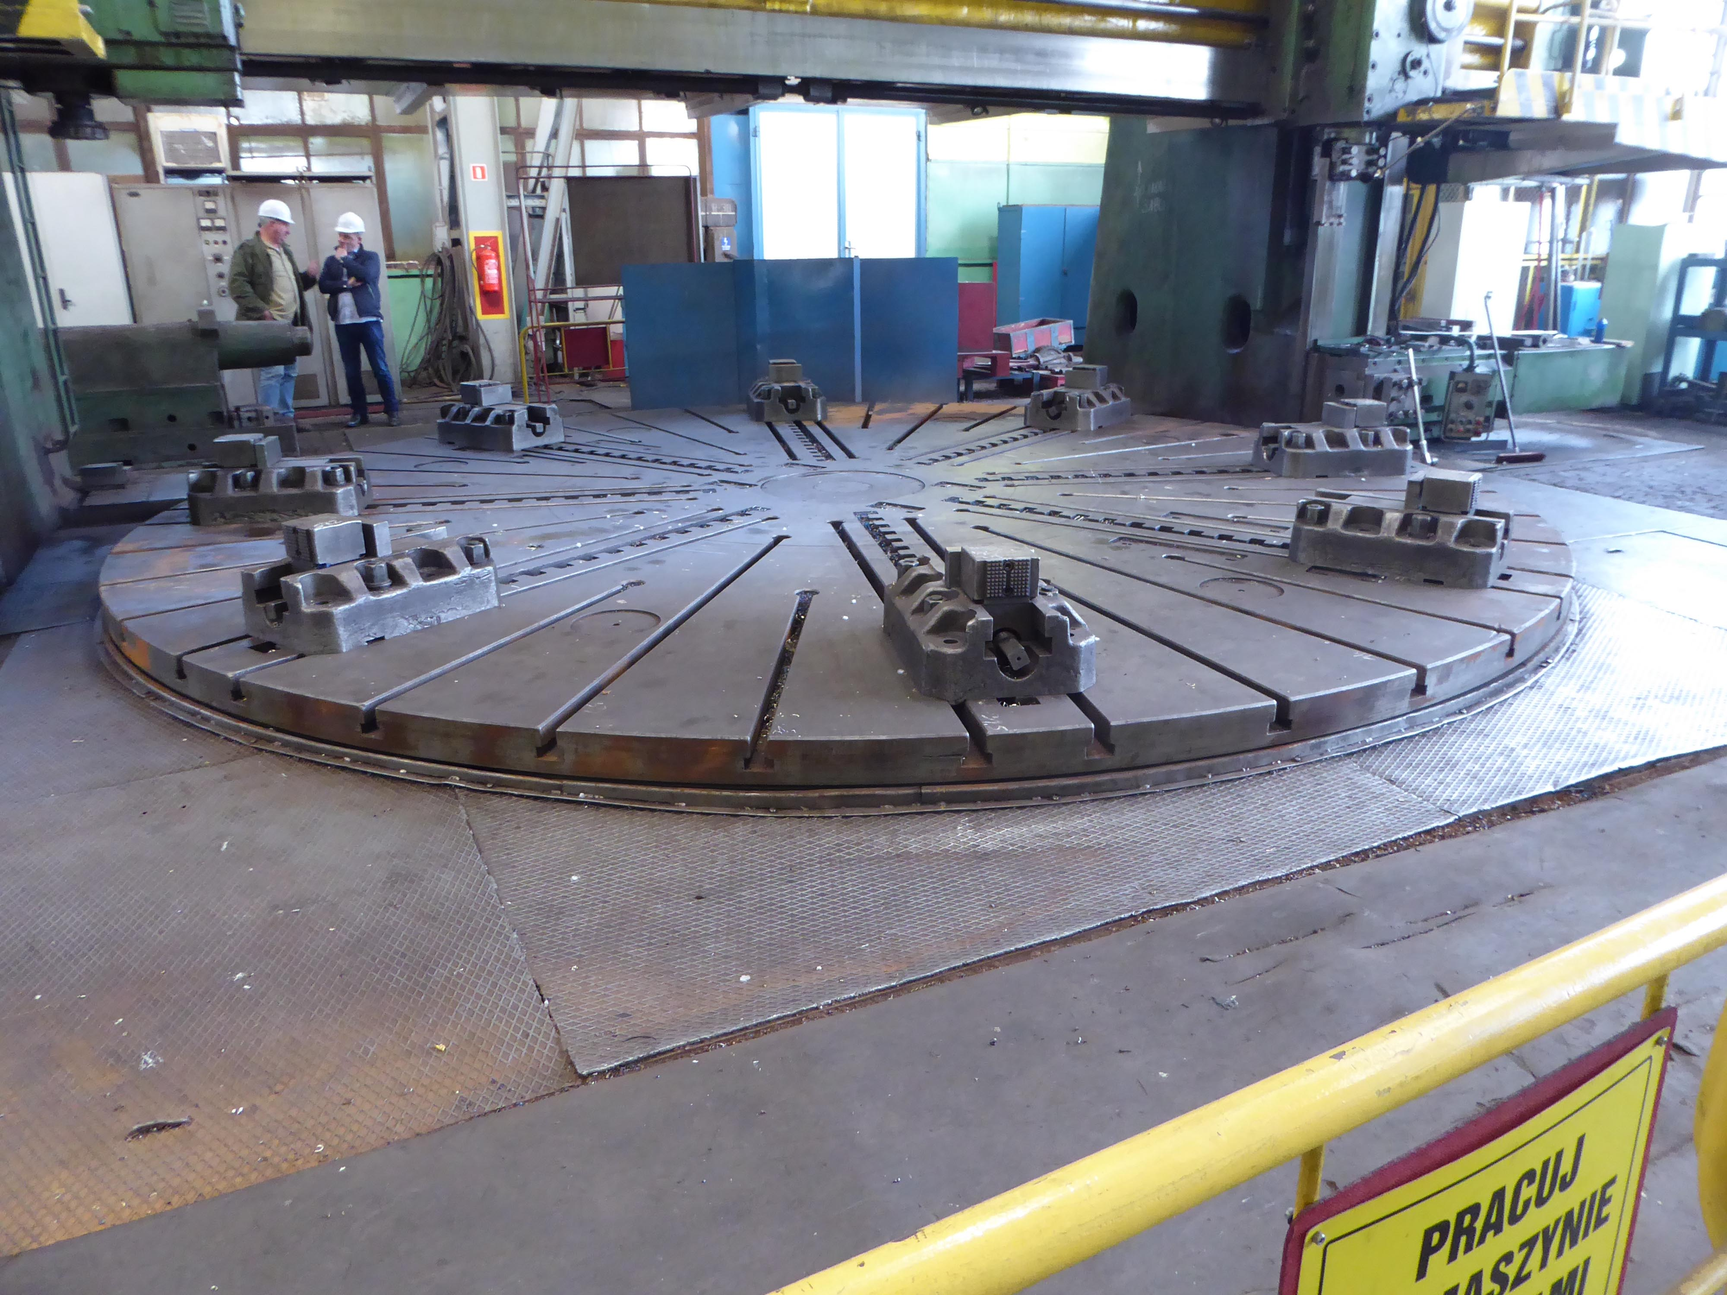
- Vert. travel left support : Z1 : 2.000
- Table load on chuck Ton : 125
- Table speed : 19.3

- Max. angle ram L & R : -15 / +30
- Cutting force ram L & R : 100 / 80
- Combined with 2 rams : 160 Nm

- Milling spindle diameter : 125
- Stroke milling spindle : 1.000
- Spindle rpm : 650
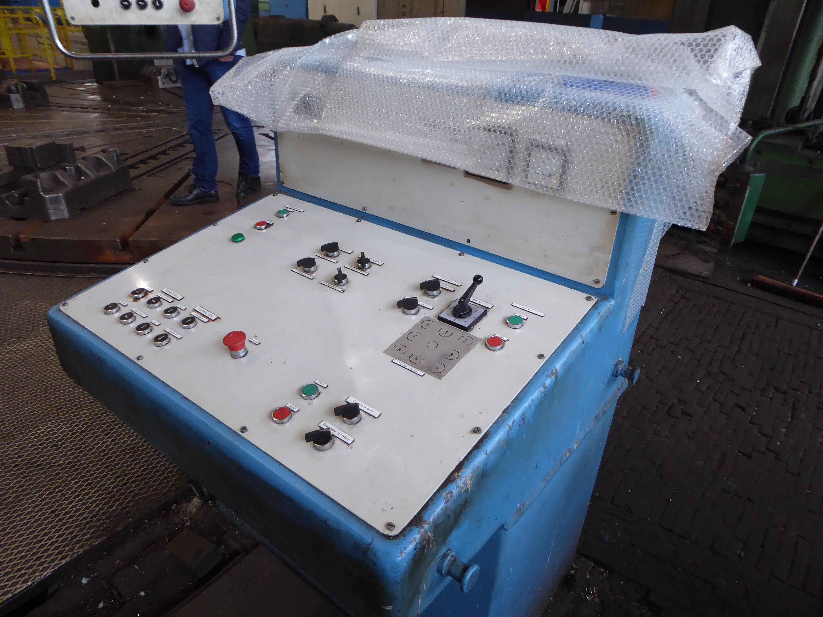
- Milling power kW : 25
- Taper Metric : 80

- Length : 8.200
- Width : 14.200
- Height : 9.000
- Weight : 230 T

- New electric
- Supports with Dro

Please Note: The above information has been obtained to the best of our ability and belief from, and from the manufacturers where possible. It is given in good faith but its accuracy can not be guaranteed. Accordingly, it will not form a representation or constitute contractual terms. We advise you to check any vital details

